Connected Route

🧱 What Is Connected Route?
# Source: AI Source: Provided by: [Data Path: Persons Table -> ID Column: 1, Name_En Column: Motasem Essam] -> From: [ChatGPT] on [1/16/2026]
A connected route is the most basic and automatic type of route in a routing table. It is created automatically by a router or host when you configure an IP address on an interface.

🧠 Simple Definition:
# Source: AI Source: Provided by: [Data Path: Persons Table -> ID Column: 1, Name_En Column: Motasem Essam] -> From: [ChatGPT] on [1/16/2026]
A connected route tells the device,
👉 “This IP network is directly attached to me — I don’t need to forward it elsewhere.”

🧾 Example:
# Source: AI Source: Provided by: [Data Path: Persons Table -> ID Column: 1, Name_En Column: Motasem Essam] -> From: [ChatGPT] on [1/16/2026]
Suppose a router has this configuration:
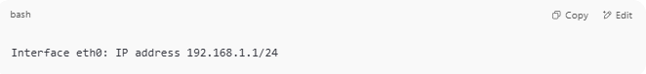
Interface eth0: IP address 192.168.1.1/24

This adds a connected route:
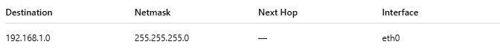
Destination | Netmask | Next Hop | Interface
192.168.1.0 | 255.255.255.0 | — | eth0
🟢 Any IP from 192.168.1.1 to 192.168.1.254 is directly reachable — no routing needed.

🔍 Characteristics of Connected Routes:
# Source: AI Source: Provided by: [Data Path: Persons Table -> ID Column: 1, Name_En Column: Motasem Essam] -> From: [ChatGPT] on [1/16/2026]
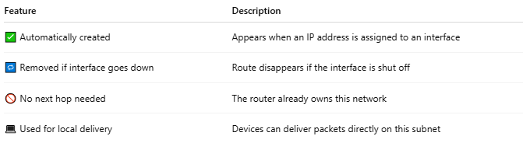

Feature | Description
✅ Automatically created | Appears when an IP address is assigned to an interface
🔁 Removed if interface goes down | Route disappears if the interface is shut off
🚫 No next hop needed | The router already owns this network
💻 Used for local delivery | Devices can deliver packets directly on this subnet

🖥 Example on Linux:
# Source: AI Source: Provided by: [Data Path: Persons Table -> ID Column: 1, Name_En Column: Motasem Essam] -> From: [ChatGPT] on [1/16/2026]
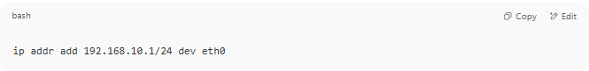
ip addr add 192.168.10.1/24 dev eth0

Auto-added routing entry:
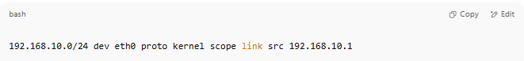
192.168.10.0/24 dev eth0 proto kernel scope link src 192.168.10.1

✅ Summary
# Source: AI Source: Provided by: [Data Path: Persons Table -> ID Column: 1, Name_En Column: Motasem Essam] -> From: [ChatGPT] on [1/16/2026]
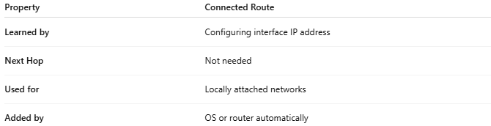

Property | Connected Route
Learned by | Configuring interface IP address
Next Hop | Not needed
Used for | Locally attached networks
Added by | OS or router automatically

